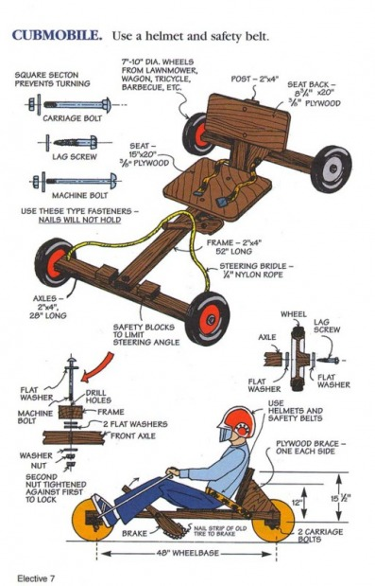
2017 Cubmobile Rules and Specifications
- Please read all of the “rules and Specifications” carefully before beginning to construct your Cubmobile. Failure to follow all of the following “Rules and Specifications” will automatically disqualify your Cubmobile.
- Wheels must not exceed 10 inches in diameter (measured to outside edge of tire).
- All wheels must be equipped with solid rubber or be inflatable.
- Car frame is made of 2”x4” construction lumber or larger. Metal frames cannot be used.
- The overall length of car is a maximum of 5 feet; the wheel base a maximum of 4 feet; and the width not to exceed 3 feet.
- Use roundhead bolts to hold frame. Screws are a second choice. Nails are not suitable and cannot be used, as they may work loose.
- All cars must have a seat with a braced backrest so the driver can comfortably steer with his feet.
- Steering is done with the drivers’ feet (which are placed on the front axle, NEAR THE WHEELS) and the hands holding a rope fastened to the front axle near the wheels. A half-hitch knot should be tied near the knees to keep the rope from slipping through the hands giving less control. No other steering mechanism is acceptable.
- If threaded axles are used, the knots must be secured with cotter pins or wires.
- Cars must be equipped with a handbrake with its rubbing surface faced with a rubber material (such as a strip of an old tire or roofing shingles). This will aid in stopping the car when dragged on the ground.
- 2”x4” safety blocks must be attached to the front axle ̋ “ from the centerboard on either side to limit the turning radius. BLOCKS SHOULD NOT HAVE MORE THAN ¼” OF PLAY ON EACH SIDE OF THE FRAME. Please see diagram
- All drivers must wear protective headgear. Scouts are to provide their own helmet.
- Please remember that Scouts are not allowed to use power tools.
- All decorations must be securely attached to car.
- Drivers must keep their feet on the axle/steering bar at all times and are not allowed to pump or push with their hands or feet.

How to Build a Cubmobile (Example)

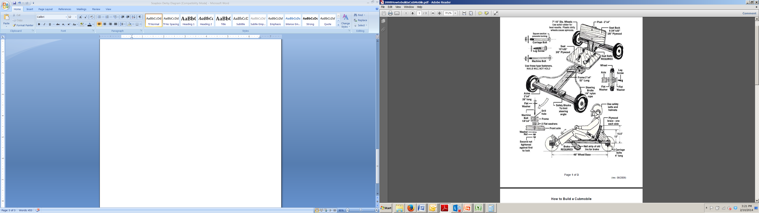

Detailed Instructions

1. Cut one 2 X 4 52" for main frame.
2. Cut two 2 X 4's 28" for axles.
3. Make an "X" on each end of each axle, and drill a hole at each "X" intersect, 6" deep using a hand electric drill (5/16" wood bit works well).
4. On front axle 2 X 4:
a. Drill a 5/16" hole on each end near the back for the rope.
b. Drill a 3/8" hole at center of 2 X 4.
c. Attach (2) 2 X 4 blocks to front axle, on either side, 2-1/8" from center hole, Use glue and #6 X 2" screws. This will limit steering.
5. At front of main frame 2 X 4, drill a 3/8" hole (center 1-5/8" from front).
6. Attach front axle to frame using 3/8" X 4" hex bolt, 4 washers, and lock nut or 2 nuts. (Tighten enough to allow steering).
7. Align back axle 2 X 4 at right angle with back of main frame 2 X 4, clamp if possible. Drill (2) 5/16" holes through axle and main frame. Attach main frame to back axle using 2 carriage bolts, 2 washers, 2 lock washers, and 2 nuts. If this is to be a permanent attachment, glue also.
8. Cut out seat and back rest from plywood.
9. Cut one 2 X 4 12-14" in length for back rest support. (Bevel slightly about 5 degrees if possible).
10. Attach back rest support (bevel end down) to main frame using glue and 2 screws (#8...21/2") at an angle. Position of this support depends on size of boy, have scout sit on 2 X 4 frame to estimate position.
11. Cut out 2 triangular shaped pieces of plywood and attach to either side of backrest support and main frame with glue and screws (#6 1-1/2"). Drilling small pilot holes helps.
12. Attach seat and back rest using glue and screws (#6...1-1/2").
13. Cut 2 X 2 surveyor's stake to 14-16" at an angle, cover end with rubber using nails, drill a 3/8" hole through stake at location it will meet main frame.
14. Drill hole 5/16" into main frame at point to attach brake. Mount brake using 3/8" X 4" lag screw and washer to side of main frame.
15. Drill and attach seat belt with fasteners of choice.
16. Attach 6-7' of 1/4" rope to front axle as shown.
17. Attach wheels using washers and 3/8" X 6" lag screws. (Socket wrench helps).

Qty Description
4 8" wheels
1 2'X4' 3/8" or 1/2" plywood
2 8' 2X4's
1 2"X2"
4 3/8" X 6" lag screws (for wheels)
1 3/8" X 4" hex bolt (for front axle)
1 3/8" X 4" lag screw (for brake)
2 5/16" X 4" carriage bolts (for rear axle)
13 3/8" washers
1 3/8" lock nut
2 5/16" washers
2 5/16" lock washers
2 5/16" nuts
32 #6 X 1 1/2" wood screws
4 #6 X 2" wood screws
1 6-7' 1/4" rope
1 seat belt (from salvage yard)
1 2" X6" piece of rubber (from old tire)
Tools you will need
Power Drill
3/8" and 5/16" wood bit
Wrenches or socket set
surveyor's stake Screwdriver
Tape measurer
Wood glue
Power or hand saw

